NC Lab 3

RegulaFalsi

11762 Muhammad Kashif

|  |  |  |  |  |  |
| --- | --- | --- | --- | --- | --- |
| S# | Function | Intervals | Tolerance | No. of Iteration | Roots |
| 1 | sqrt(x)-cos(x) | 0,1 | 0.01 | 3 | 0.64 |
| 0,1 | 0.001 | 4 | 0.642 |
| 0,1 | 0.0001 | 6 | 0.6417 |
| 2 | 3(x+1)(x-1/2)(x-1) | -2, 2' | 0.01 | 15 | -0.999 |
| -2, 2' | 0.001 | 17 | -0.9998 |
| -2, 2' | 0.0001 | 21 | -0.99998 |
| 3 | 2x cos(2x)-(x+1)^2 | -1,1 | 0.01 | 2 | 0.79 |
| -1,1 | 0.001 | 3 | 0.796 |
| -1,1 | 0.0001 | 4 | 0.7979 |

Task 1

Question m.sqrt(x)-m.cos(x)

Code

def f(x):

return m.sqrt(x)-m.cos(x)

def regulafalsi(xL,xU):

for i in range(15):

xroots = (xU*f(xL)-xL*f(xU))/(f(xL)-f(xU))

if f(xroots)<0:

xL=xroots

print(i,"Change in xL ",xroots)

else:

xU = xroots

print(i,"Change in xU ",xroots)

root = f(xroots)

if root <= 0.01:

break

regulafalsi(0,1)

Output

Tol = 0.01 Tol = 0.001

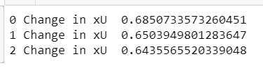 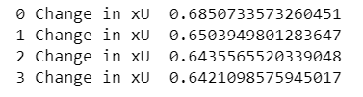

Tol = 0.0001

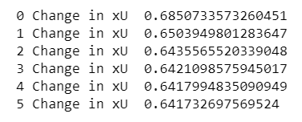

Task 2

Question 3(x+1)(x-1/2)(x-1)

Code

def f(x):

return 3*(x+1)*((x-1)/2)*(x-1)

def regulafalsi(xL,xU):

for i in range(15):

xroots = (xU*f(xL)-xL*f(xU))/(f(xL)-f(xU))

if f(xroots)<0:

xL=xroots

print(i,"Change in xL ",xroots)

else:

xU = xroots

print(i,"Change in xU ",xroots)

root = f(xroots)

if root <= 0.01:

break

regulafalsi(-2,0)

Output

Tol = 0.01 Tol = 0.001

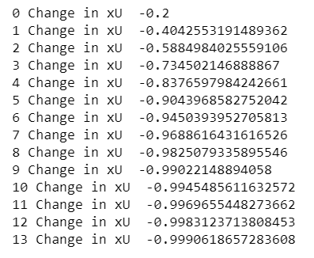 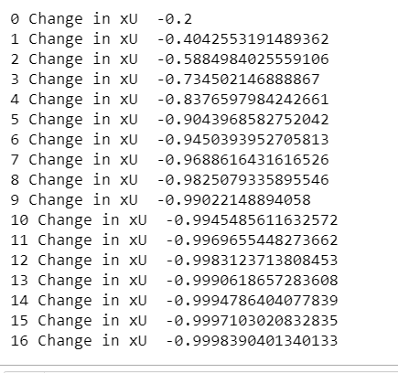

Tol = 0.0001

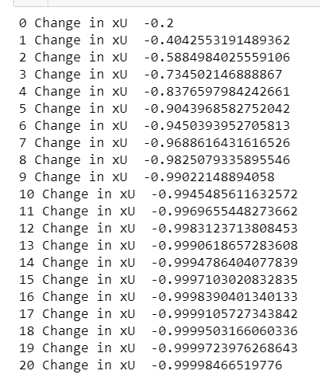

Task 3

Question 2*x*m.cos(2*x)-(x+1)**2

Code

def f(x):

return 2 *x*m.cos(2*x) - (x +1)**2

def regula_falsi(a,b, tol=0.01):

fa= f(a)

fb= f(b)

for i in range(100):

c = (a*f(b) - b*f(a))/(f(b) - f(a))

fc = f(c)

if abs(fc) < tol:

return c

if fa*fc < 0:

b = c

fb = fc

print(i,"Change in xU ",c)

else:

a = c

fa = fc

print(i,"Change in xL ",c)

return

regula_falsi(-1,1)

Output

Tol = 0.01 Tol = 0.001

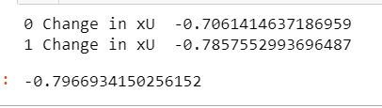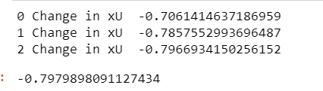

Tol = 0.0001

